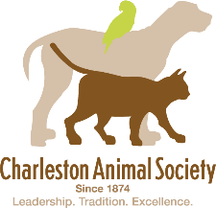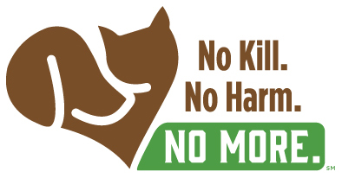

Dear Foster Family,

Welcome to Charleston Animal Society!

You have joined the ranks of hundreds of families who, like you, are committed to saving the lives of the most vulnerable among us – animals who have been abandoned, neglected, abused or who are simply unwanted.

Many of these helpless animals are neonatal kittens who have been separated from their mothers in the most fragile of conditions. Without you, they will not survive!

With the help of kind souls like you, we have managed to build one of the most effective lifesaving armies in the nation. Our foster program is built upon a solid structure. Although it may seem that we have a lot of policies, procedures and protocols to follow, they provide pillars of strength for the program and we ask that you make every effort to follow them, remembering that we’re all on the same lifesaving team!

I want to take this opportunity to thank you with all of my heart because our foster families are the last safety net for hundreds of animals each year. It is a challenging but amazing experience. If you come upon a time when you feel overwhelmed, please reach out to our support staff or other foster families who have been through similar experiences. You’ll find them to be a mountain of support.

Most of all, please remember that the fragile and adorable animals in your care are depending on you to give them their best chance at surviving in this world. Keep in mind, there are going to be times when the most fragile of animals do not make it. Please know that you have given it the best chance at survival and that, without you, it would not have had any chance at all.

You are nothing short of a Godsend to these animals and Charleston Animal Society!

Thank you!!!

Best,
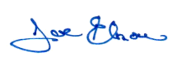
Joe Elmore, CFRE, CAWA
Chief Executive Officer
South Carolina’s First Animal Organization Most Honored Charity!

